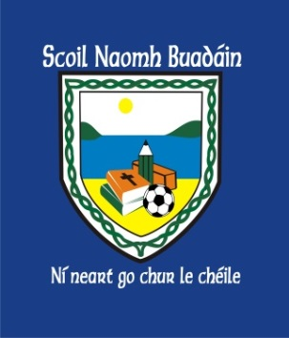 | St. Boden’s N. S.  Newsletter  May 2017 | 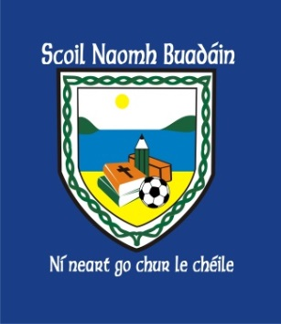
Thank you
Once again, a huge thank you to all of you, the parents, for your continued support and positivity!
Your interest and involvement in supporting the school is admirable and really appreciated!

School Uniform

The Board of Management, with the help of the Parents Committee have discussed regulating the school uniform.
We understand the rising costs of running a family so it is suggested in the future our uniform will be:
-V Neck jumper
- Royal Blue
- Include school crest
- No personalisation
- Light blue Polo shirt
- Plain navy tracksuit bottoms
Our Parents Committee researched a local supplier ‘Pure Savage’ who is willing to provide a very high quality jumper at a low price – €15!
Should you choose this option, we will have a ‘jumper fitting’ session from 2 – 4 pm on June 8th, Thursday in school hall.
Parents are invited to take their children to the PE hall,
try on jumpers and order the appropriate size.
Plain navy tracksuit bottoms / polo shirt can be bought from a shop of your choice.

June Bank Holiday:  School is closed Monday, June 5th.  Early Closure  School will close for ALL pupils at 2pm on June 6th to allow for termly staff meeting. | Enrolment Forms  Available in office or to download on www.stbodensns.ie  Some available in Bocan Creche Office also!  Sports Day:  Tuesday, June 20th (weather permitting!)

St. Boden’s N.S.
Parents Association Newsletter
We are very pleased to let all you parents know how successful you made
St Boden's first 5k making a profit of 1621.90 EURO. Amazing results!
Thank you everyone who helped in anyway took part and especially all the sponsers: -
Balance personal training nutritional advisor, Fun Fitness Studio & Gym, Blue Ocean Complementary Therapies, John Cassidy and son plant hire, Shoe & Sport Store, Bonnor Inn Culdaff Arms, Bernard Mc Guinness Bar & shop, McGrory's Hotel, Ballyliffen lodge & spa, Redcastle plant hire, Neil Doherty jeweller's, AIB Carndonagh. Thank you to Inishowen Athletes and Niall Mc Gee.
We couldn’t have done it with out their help!
Ceili in Bocan hall made a profit of 543.62 euro. Thank you to Angela Mooney for letting us have the Ceili and thank you to the parish for the use of the hall and all who attended and all who provided refreshments. We would also, like to thank Angela Mooney for her kind donation of 210 euro from Ceili funds!
A very generous donation! Thank you Angela!

Upcoming fundraisers are the Church gate collection on 20th and 21st May
and the return of the Copper coin collection bottles.
Keep filling! Loads of bottles still available in school!

It would be great if a few parents were available to help with first Communion tea as a lot of this year’s PA are involved in the First Holy Communion Celebrations!
Please let a member of the PA know if you are available to help on the 20th of May! We’d really appreciate it!
We also would like to let everyone know what they have fundraised to date this year …11660.89 euro
Thank you everyone for the support
A date will be organised for next PA meeting near the end of June and sent out by text or letter!

ST BODEN'S PARENTS ASSOCIATION

