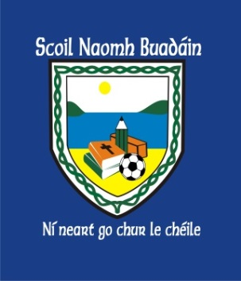 | St. Boden’s N. S.  Newsletter  March 2017 | 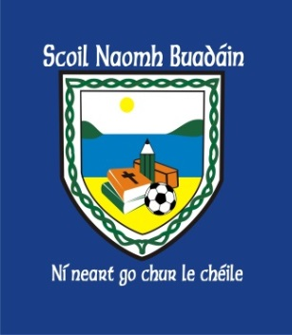
Thank you
A huge thank you to all our parents for volunteering and helping with events organised by the Parents Association over recent weeks. The Parents Associations fundraising efforts are phenomenal. It is much appreciated and helps to purchase much needed resources to the school.
Thank you to everyone who contributed their time and money!

Grandparents Day
Grandparents Day will take place on Wednesday, March 15th at 11:00am in the hall.
From there you are invited to visit the classrooms and return to the PE hall at 12:00am for some refreshments. We look forward to hosting you in our school!

Lá Glas  Children dress up and come to school in traditional colour green to celebrate  ‘Seachtain na Gaeilge’ on Thursday, March 16th | Confirmation  Confirmation mass will take place in Bocan Church on Saturday, March 11th at 11:00am.
Enrolment Forms
Available in office or to download on www.stbodensns.ie
Some available in Bocan Creche Office also!

5km Fun Run
A 5km fun run will take place on Saturday, March 18th.
Registration begins at 10:30am in the school hall.
Race starts at 12 noon!
Entry: Adult €8 and child €5 and Family €20.

Easter Holidays
School will be closed Monday 10th April
School reopens April, Monday 24th @ 9:20am.

