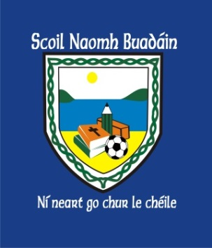 | St. Boden’s N. S.  Newsletter  January2017 | 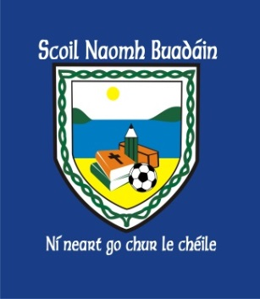
A warm, happy and safe new year to you all! We have lots of activities lined up for Term 2!
Check out the details below!

Choir  3rd – 6th class  Tuesday 11:15 – 12:15 | Soccer  4th – 6th class  Monday 1:00 – 2:00
GAA  Junior & Senior Infants  Wednesday 11:30 – 12:30 | Tin Whistle  1st – 3rd class  Thursday 11:35 -12:15
Cookery classes  6th Class  Tuesday 1:00 – 2:00 | Junior Entrepreneur Programme  4th – 6th class group project.  Currently negotiating a ‘Big Idea’ to work on as a team!
Bus Éireann - Red Weather Warning
Reminder to parents that the bus will not run if a red weather alert has been issued by MET Eireann. The BOM has decided the school will close on the first day of a red weather warning. Parents will be alerted by text for any succeeding days.

Adult Education  Story sacks Literacy course!  Show your children the importance of education by coming to school and creating resources that can be used in the classroom.  Please return expressions of interest to the office or your child’s teacher! | Parents Association Meeting  Next meeting to be held on  Monday, January 31st @8pm
Operation Transformation
To celebrate 100 days at school, we are taking part in
‘Operation Transformation’s 10@10am on February 10th!
The children will be challenged to complete 100 exercises in 10 minutes!
Most primary schools in the country will be taking part at the same time so check out
‘@stbodensns’ on twitter and www.sbodensns.ie for details!

