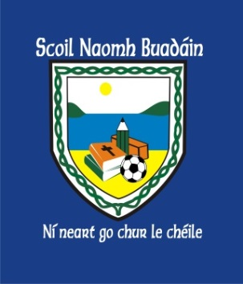 | St. Boden’s N. S.  Newsletter  February 2017 | 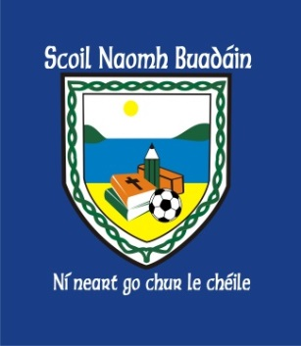
Green Schools Committee
Congratulations to all the parents and children taking part in our ‘park&stride’ initiative to encourage the children to exercise. It’s great to see the children walking and cycling to school!

On Feb 17th we will all meet at Caratra @9am and walk to school together. Looking forward to seeing you there!

Operation Transformation: 10@10
Thank you to Lisa Mills who guided the children with 10 minutes of exercise at 10 o’clock on February 10th! We had super fun!

Junior Entrepreneur Programme
Another big thank you to Bernard McGuinness and Jason Doherty who helped to judge our ‘Dragons Den’ in 4th – 6th class.
We decided our ‘Big Idea’ is going to be creating an educational board game called ‘Concentration’!
The marketing and design team are busy! Game will be for sale soon!

Enrolment Forms
Available in office or download on www.stbodensns.ie
Some available in Bocan Creche Office also!

Adult Education
Literacy Course (Storysacks) has been cancelled due to attendance.
More Adult Education courses will be available early next school year.

Midterm Break
School will be closed Monday 20th – Friday 24th.
School reopens Monday 27th @ 9:20am.

